Kol simcha torah gazette
For parshas ki savo 5784
Volume 8 Issue 52 (Whole #412) 18 Elul 5784/ September 21, 2024
Printed L’illuy nishmas Nechama bas R’ Noach, a”h

For a free subscription, please forward your request to keren18@juno.com
Past emails can be found on the website ShabbosStories.com under Brooklyn Torah Gazette
Making This Year’s Teshuva a Different and Powerful Experience
By Daniel Keren

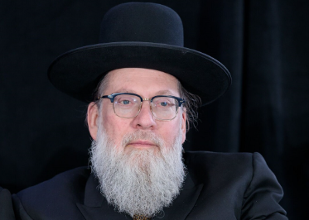
Rabbi Moshe Tuvia Lieff

One of the featured speakers at the recent Flatbush Labor Day Hakhel Yarchei Kallah Event was Rabbi Moshe Tuvia Lieff, the Mora D’asra of the Agudath Israel Beis Binyomin and the topic of his lecture was “Making This Year’s Teshuva Different.”
He began with a story that reflected on the importance of the month of Elul. Back in Kelm there was a Yid who went to a non-Jewish lumber merchant to negotiate the purchase of certain amount of lumber that he needed for a certain project. After coming to terms on the cost, he instructed the goy to deliver the lumber to his home and he would pay him COD (cash on delivery.)
The non-Jew refused and insisted on being paid in full before he would make any delivery. He had too many times been burned by people who had promised to pay him after he delivered the desired lumber. The Jew and lumber merchant’s argument began getting more heated and it appeared that they would start actually physically attacking each other.
All of a sudden, another goy ran up and tapped his fellow non-Jew on the shoulder and explained to him that he had nothing to fear from doing such an arrangement with the Jew that day. He said that it is impossible for a Jew to dare even think of doing anything wrong and going back on his word as it was the Jewish month of Elul and as all the Jews in town were busily preparing to get ready for the awesome days of Rosh Hashanah and Yom Kippur. Therefore, no Yid would ever do anything dishonest even to a goy in these days of Elul.

The Jew Who Only Came to Shul
on Rosh Hashanah and Yom Kippur
Rabbi Lieff told another story about a Jew who was not frum, but to honor his father’s memory would always come to the shul on three days a year on Rosh Hashanah and Yom Kippur. One day, a few weeks ahead of the holy days in the month of Elul he called the rabbi of the shul to tell him that he wasn’t anymore coming to shul to pray on those days. The rabbi, of course, asked why and was told by the simple Jew that he had just purchased an ArtScroll Machsor for the Yomim Noraim.
The Jew noticed in the translation that we pray to Hashem to put His fear or dread upon us. “Why do I need this!? I already fear my wife. I fear my boss. At times I fear my kids. I fear my investments in the Dow Jones going down. Why do I need another thing to fear or dread?”

Hashem Can Help You with Your Mundane Fears
The rabbi explained that if you have a pachad because of Hashem, you should know that He is merciful and forgiving, especially if you do teshuvah. And consequently, you won’t have to worry about the mundane fears as He can easily help you out in those areas of your life.
Rabbi Lieff spoke of the Yud Gimmel Middos of Rachamim (Hashem’s 13 Attributes of Mercy.) It can be compared to a soda dispensary that has many buttons. One is for Coke or Pepsi, another is for seltzer, a third for Sprite, etc. The object is focus on each of the middos of Hashem’s attributes of mercy. Each time we sincerely press a button for a particular middos, Hashem reacts by forgiving us, allowing us to turn aveiros (sins) into mitzvos (merits).

We Should Not Allow Others
to Put Out Our Spiritual Light
The yesod (foundation) of this Tekufah [period in the Jewish calendar of Chodesh Elul and the Yomim Noraim] is to take advantage of the flash of lightening that Hashem gives us at this unique time of the year. Our avoda (spiritual service) and challenges at this time is not to allow others to put out our spiritual light (desire to do teshuvah and come closer to Hashem) because they themselves don’t want to improve themselves.
Rabbi Lieff concluded by explaining that if one increases at this time one’s learning of Torah, this is an excellent method to be mechaper (atone for one’s sins or spiritual failures.) Today when we don’t have the Beis Hamikdosh to bring karbones (sacrificial offerings to atone for specific sins), our learning Torah can be a replacement because Talmud Torah both refines and elevates us. May we all be worthy for a sweet and good new year.

Reprinted from this week’s edition of The Flatbush Jewish Journal.

******************************************************************
And it shall be, when you come into the land...you shall take of the first of all the fruit of the earth, which you shall bring of your land that the L-rd your G-d gives you (Deut. 26:1-2)
One of the reasons for the mitzva of bikurim, first fruits, is that bringing the first of the land's produce to the Holy Temple negates the mistaken notion that the fruits are the result of the farmer's efforts and agricultural acumen. The mitzva reminds him that all of the earth's bounty is ultimately dependent on G-d's blessing, and nothing else. (Akeidat Yitzchak)

All these blessings shall come on you, and overtake you (Deut. 28:2)
What does it mean that the blessings will "overtake you"? That they will come to you in the same place you were before: i.e., that you will not wander astray, off the path of Torah and mitzvot, in your pursuit of wealth and success. (Chashva Letova)

Reprinted from the Parashat Ki Tavo 5761/2001 edition of L’Chaim.
Rabbi Berel Wein on
Parshat Ki Tavo 5784

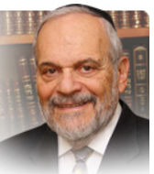

In this week’s parsha, all of Jewish history is reflected in the two relatively short scenarios that the Torah describes for us. The opening section describes the promise that the Jewish people will come into the Land of Israel, settle there and develop the country, build the Temple and express their gratitude to G-d for the blessings that He has bestowed upon them. They will harvest bountiful crops and commemorate these achievements by bringing the first fruits of their labor as a thanksgiving offering to the Temple and the priests of the time.

They will then recite a short statement of Jewish history, a synopsis of the events that have occurred to them from the time of the patriarchs until their own time. The Torah promises blessings and serenity to the people of Israel. The Torah does not minimize the toil and travail that led to the moment of these offerings in the Temple. However, it does convey a sense of satisfaction and achievement, of gratitude and appreciation, for the accomplishments of the Jewish people, individually and nationally, regarding the Land of Israel and its bounty.

It is a spirit of wondrous gratitude that marks the accomplishments of the individual farmer and of the people generally in settling and developing the Land of Israel. There is little room for hubris and self-aggrandizement in the set text of this offering in the Temple. Rather, the text highlights the relationship between G-d, the Land and the people of Israel. That is the first scenario that is outlined for us in this week's parsha. The second scenario in the parsha is a much more somber and even frightening one. It describes the events, travail and persecution that will visit the Jewish people over the long millennia of its exile from its land. In vivid detail, the Torah describes the horrors, defeats and destruction that the Exile will visit upon the Jewish people. In our generation, this portion of the Torah reading can actually be seen on film and in museums.

We are witness to the fact that not one word of the Torah’s description of dark future events was an exaggeration or hyperbole. This period of trouble and exile lasted far longer than the initial scenario of the offering of the first fruit in the Temple. And, unfortunately, the residue of this second scenario is still with us and within us as we live in a very anti-Jewish world society.

Yet we are to be heartened by the concluding words of this section of the Torah that promises us that it will be the first scenario of this week's parsha that will eventually prevail. Even though so much of the negative is still present in our current state of affairs, we should be grateful for our restoration to sovereignty and dominion in our own homeland and for the bounty of the land that we currently enjoy. All of this is a symbol of the beginning of the resurrection of the first scenario and the diminishing of the effects of the second scenario. May we all be wise enough to realize this and adjust our attitudes and actions accordingly.

Shabbat shalom

Reprinted from the current rabbiwein.com website.
*****************************************************
Because you didn't serve the L-rd your G-d with joyfulness and with gladness of heart, for the abundance of all things, therefore shall you serve your enemies (Deut. 28:47-48)
How great is the importance of happiness in our Divine service! From the wording of the text we understand that the punishment of "serving your enemies" comes not because of a deficiency in observance or any actual defect in service, but simply because of a lack of joy. Indeed, the emotion of joy is so powerful that it produces a reciprocal response from Above, causing G-d to nullify strict judgment. (The Alter Rebbe, Rabbi Shneur Zalman)

Reprinted from the Parashat Ki Tavo 5761/2001 edition of L’Chaim.
Rav Avigdor Miller on
Assassinations Attempts

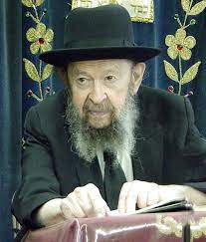

QUESTION: What can we learn from the shooting of the Pope?
ANSWER: We can learn that a time has come to do something about crime. And you have to know who is to blame? The Pope is to blame. And if you’ll ask me who is to blame for shooting the President? The President is to blame.
All the people who are suffering from crime are to blame. And if chas v’shalom Jews suffer, the Jews are to blame. Because something could be done about crime and nothing is being done. If people who are sincere would speak up and they’d talk with sharp teeth to the legislators, something would be done about crime. It’s so silly to make big studies about how to check crime.
Somebody was saying when the President was shot, it proves we need gun control. That’s as silly as could be! What we need is – a writer wrote this recently: ‘We don’t need gun control; we need scum control.’ It means we have to control those scum that are teaching the children in the public schools that they should do whatever they want. They teach them to kill just for the deviltry, just for the fun of it. That’s what’s going on today. The schools are as rotten as can be.
If we wanted to stop crime, we would start in the schools. We would knock out, we would throw out all the psychologists and psychiatrists, all those wicked people who write books today; the textbooks are as rotten as can be. They encourage children to express themselves in the craziest way.
We would step into the television stations and we’d tell them, “Either stop encouraging crime or else you’ll lose your license!” Because you cannot encourage free speech if it endangers the lives of others. We would have mandatory capital punishment for murderers. And the world would suddenly become better.
It’s so easy to restore law and order, but only when the people want. The people don’t want it – the people are full of compassion for murderers and that’s why they’re getting bullets. When you have compassion on murderers, that’s the result.
And therefore, the shooting of the Pope teaches us like the shooting of the President, it’s high time for us to get busy. Especially the frum Jews! We are the ones that have the most sense and we shouldn’t be asleep. All the frum Jews should be up in arms for law and order. Not to vote for politicians who will give us money for programs for Orthodox organizations, for yeshivas. We don’t want that! We want politicians who will vote the way we want for our safety. We’ll fight for law and order! And those politicians or those Orthodox organizations who don’t go along with us, we’ll boycott them and we’ll force them!
The trouble is we’re not doing it and therefore we are suffering what our laziness brings upon us. It’s our own fault. That’s the lesson that we learn from the shooting of the Pope.

Reprinted from an email of Toras Avigdor (Tape #362 – May 1981)

*********************************************************************

And all people of the earth shall see that you are called by the name of the L-rd, and they shall be afraid of you (Deut. 28:10)
Through you, the Jewish people, the nations of the world will acquire fear of G-d. Because "you are called by the name of the L-rd," it will influence the people around you, and they will come to fear Him. (Butzina D'Nehora)

Reprinted from the Parashat Ki Tavo 5761/2001 edition of L’Chaim.

The Continual Partnership of
the Jewish People and G-d
From the Teachings of the Lubavitcher Rebbe
Rabbi Menachem Mendel Schneerson, Zt”l
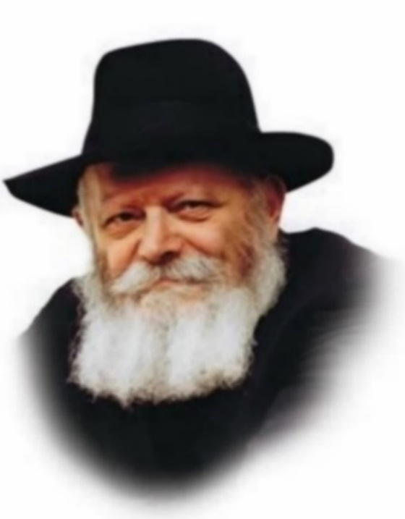

In this week's Torah portion, Ki Tavo, we read: "This day the L-rd your G-d commands you to do these statutes and ordinances." Rashi, the foremost Torah commentator, explains, "Every day they should seem new in your eyes, as though on that very day you were commanded regarding [Torah and mitzvot]."
The portion continues with the verse, "You have set apart the L-rd this day to be your G-d and to walk in His ways...and the L-rd has set you apart this day to be His own treasure."
From this we learn that the "setting apart" of G-d to be our G-d, and His "setting apart" of the Jews to be His people, is also a daily and ongoing occurrence.
Each and every day G-d chooses the Jewish people, individually and collectively, as His "treasure," and as the verse continues, "in praise and in name and in glory...a holy people to the L-rd your G-d." G-d glories and takes pride in the Jewish people, each of whom is described as "the work of My hands to be praised." G-d "boasts," as it were, about every Jew, through whom His Name is glorified and exalted in the world.
And as stated above, the delight G-d takes in the Jews and the Jews in Him, is "new" each and every day, as fresh as if the Torah was just revealed on Mount Sinai.

The Torah portion of Ki Tavo is always read in the month of Elul. As everything in Torah is exacting and nothing occurs by coincidence, it follows that the above must somehow be connected to the special service of this month, preparatory to Rosh Hashana.
Rabbi Shneur Zalman, founder of Chabad Chasidim, explained that in Elul, G-d is likened to a "King in the field." Outside the strict protocol of the royal palace, everyone is granted an opportunity to approach the King, speak with Him directly and present Him with our requests. Moreover, during Elul, G-d "greets everyone with a smiling countenance and shows a pleasant demeanor to all."
For this reason, "You have set apart the L-rd this day to be your G-d and to walk in His ways...and the L-rd has set you apart this day to be His own treasure," is particularly relevant now, when every Jew has this special opportunity and capacity for connecting to G-d and glorifying His Name. And because G-d shows us a "smiling countenance" and a "pleasant demeanor," it makes all of our Divine service easier and more successful.

Reprinted from the Parashat Ki Tavo 5761/2001 edition of L’Chaim. Adapted from a talk on 14 Elul 5740.

Don Yitzchak Abarbanel: A Torah Scholar for Our Open Society
By Dr. Meir Tamari

This Torah scholar, diplomat, financier, mystic and leader of his people, although living some five centuries ago, is particularly pertinent to the modern open society and global village in which we live, in a way that no other scholar seems to be. He is probably the last person to combine within his person four major and long existent Jewish traditions; philosopher, statesman, torah scholarship and cabbalist.
His commentary on the Torah seems particularly suitable to those of us who earn our livelihoods, engage in business or professions and willy-nilly are confronted with the challenges of living globally, for the first time since his period, in free societies.
Faced with the challenges inherent in the cultural and religious free market of his time – 15th century Spain, his knowledge of Torah, philosophy, both Jewish and that of classical Greece and European Renaissance, and mystical sources, he presents a commentary suitable to us living in a similar assimilatory prone, open and spiritually free society.
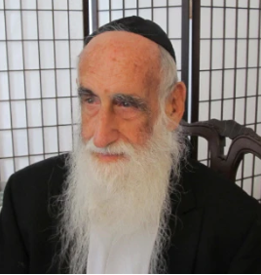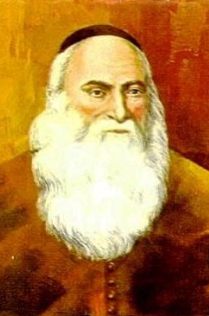
Dr. Meir Tamari, a”h and an illustration of the Abarbanel, zt”l

As a scion of traumatic Jewish expulsion, persecution and suffering, his ideas of galut, redemption and messianism are extremely relevant to our post holocaust generation. Adopting a special Socratic style of detailed questions and answers, he produces a commentary on the Chumash and the Nach that is familiar and convenient for us trained as we are, knowingly or unknowingly, in Greek methods of thought and those of science and technology. Furthermore, he constantly refers to the classical commentators who preceded him- Rashi, Rambam, Ibn Ezrah, Ralbag and Ramban. However, he then goes on to supply his own comments reflecting his own very specific approach.
Biography
He was born in Lisbon, Portugal, in 1437, into a family descended from King David that ranked in the forefront of the Jews of the Iberian Peninsula. They were distinguished by their financial, political and Jewish communal leadership achievements.
In addition, they were known as a family that loved scholarship, and piety, and had strong moral convictions. All these as well as their commercial and financial strengths Don Yitzchak inherited. Then in 1483, with the ascension of the anti-Semitic king Joao, he was forced to flee to Spain, where he re-established himself till the expulsion of Spanish Jewry in 1492.
Ultimately he made his way to Italy, where he lived in Naples and Venice till his death in 1508. [Dr. Meir Tamari, 1927-2021 was a renowned economist, Jewish scholar, and founder of the Center For Business Ethics (http://www.besr.org) in Jerusalem.]

Reprinted from the Parashat Ki Tavo 5784 email of R’ Yedidye Hirtenfeld’s whY I Matter parsha sheet for the Young Israel of Midwood in Brooklyn, NY.
This Hostage Said This Prayer Every Day
By Mendy Kaminker


Art by Sefira Lightstone

“G-d is my light and my salvation; whom shall I fear? G-d is the stronghold of my life; from whom shall I be frightened? ... My adversaries and my enemies against me? They stumbled and fell!”¹
Last week, together with hundreds of thousands of Jews worldwide, I began reciting Psalm 27 twice a day—an ancient tradition beginning on the first day of the month of Elul and continuing until Hoshana Rabbah.
But this year, Psalm 27 holds a new and deeply moving meaning for me.
On Rosh Chodesh Elul, the day we began reciting the psalm, I received a video clip that shook me to my core. In it, Sapir Cohen shares her incredible story about this very Psalm.
A few months before October 7th, Sapir felt an overwhelming sensation that something terrible was on the horizon. Convinced she was facing a terminal illness, she made an appointment with her doctor for a full health check. Everything came back normal, but she couldn’t shake the sense that her life was in danger.
In her search for answers, she came across a suggestion online: recite Psalm 27 for 30 days in a row, and it would bring healing from sickness. Desperate for a solution, she did exactly that, saying the psalm every day for a month.

Sapir Cohen

The last day was October 7th.²
“I remember how, in the last week of reciting Psalm 27, I started paying closer attention to the words,” Sapir recalled. “I was confused – this psalm talks about enemies and evildoers, but I wasn’t fighting enemies; I thought I was sick. How did this apply to me?”
But on that terrible day, when terrorists broke into her bomb shelter, Sapir’s fear turned into clarity. “Suddenly, I remembered the words of the psalm, and I knew: I would survive.”
Sapir continued reciting the psalm—the only prayer she knew by heart—every day during her captivity. One day, her captors even asked her if she knew how to pray, and suggested she do so out loud. It was a surreal moment for her, sitting there with her captors, saying King David’s words: “My adversaries and my enemies against me? They stumbled and fell!”
Thank G-d, she was released and is now safely back home.
Hearing this story on Rosh Chodesh Elul imbued the recitation of Psalm 27 with new significance for me. Thinking of Sapir and her faith helps strengthen my own.
Unfortunately, we still have many enemies, and many of our brothers and sisters remain in captivity, desperately needing our prayers. As we continue through this month of Elul, let’s unite in saying Psalm 27 daily, praying for their safe return and for peace.
In the words of the final verse of Psalm 27:
“Hope for the L-rd, be strong, and He will give your heart courage. Hope for the L-rd!”
Footnotes
1. Psalms 27.
2. It’s very possible that she came across the custom of saying this Psalm every day of Elul, concluding in the last day of Hoshana Rabbah.

Reprinted from the current website of Chabad.Org

